Donor Email Templates
Below is customizable text and copy for five donor emails, with banner images sized accordingly. Here is an overview of what is included:
- Welcome
  - 1a. Workplace campaign kickoff
  - 1b. Company CEO welcome
- Why United Way?
  - 2: Our value-add
- Reminders
- Thank You (post- campaign)

Phase 1: Welcome
Email 1a: Campaign Kick-off
From: Your United Way CEO
Audience: All company employees
Header:
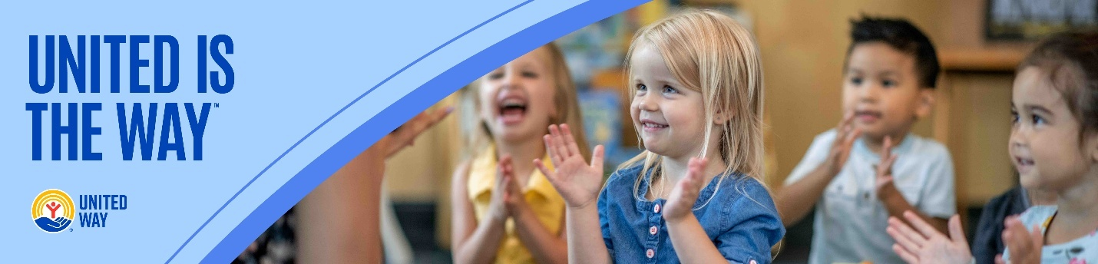
Subject Line: United is the Way to change lives in Sandusky County.
Email Body:
[NAME],
Today, so many of our neighbors in Sandusky County are working hard to overcome barriers and get ahead.
Somewhere in our community:
A working parent is looking for a way to make this week’s paycheck cover the growing costs of groceries, prescriptions, and housing.
A middle-schooler is struggling to find a way to stay focused in class because she didn’t get a nutritious breakfast this morning.
A high school grad is searching for a way to turn his diploma into a good-paying job and a promising career.
But they’re not alone.
Together with our community-serving partners and supporters like you, we can connect people to the opportunities they need to reach their full potential and make Sandusky County a place where everyone can thrive.
Donate today and join us in creating more thriving communities for all. No challenge is too big for us to take on if we work together.
Because, United is the Way™.
Best Regards,
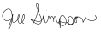
Jill Simpson
CEO/President
United Way of Sandusky County
director@uwsandco.org

Email 1b: Company CEO Welcome
From: Company CEO, Leader, or Employee Campaign Chair’s first and last name
Audience: All company employees
Header:
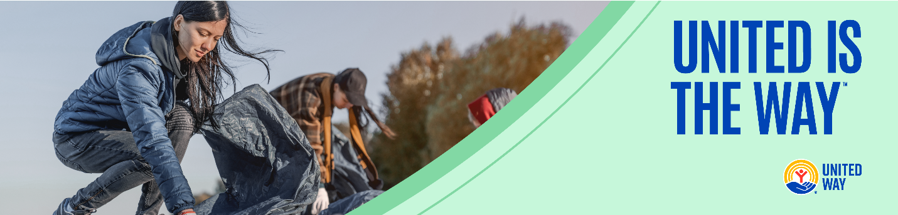
Subject Line: [Company Name] Team, please join me in supporting our neighbors in Sandusky County.
Email Body:
At [COMPANY NAME], we believe in giving back to the communities where we live and work. That’s why I’m proud to support our friends at United Way of Sandusky County– and I’m inviting you to join me.
Every day, United Way – with the support of community-minded partners, volunteers, and donors like us – is working hard to ensure that everyone has access to essential services and resources they need to thrive, including:
- Nutritious food and access to quality health care our neighbors need to lead healthy lives.
- Childcare, early learning, education, and enrichment to set kids up for success from cradle to career.
- Counseling, career training, and housing support to help families not only make ends meet, but create a sustainable financial future.
- Emergency preparedness and disaster recovery efforts to ensure that our community stays connected, strong, and resilient, no matter what challenges we may face.

Please consider making a one-time or recurring gift to support this powerful work and send a message of solidarity and compassion to our neighbors most in need. Together, we can make a transformative impact in our community.
United is the Way™.
Thank you in advance for your generous support.
Sincerely,
[CEO Name]
Phase 2: Why United Way?
Email 2: Our Value-Add
From: Your United Way CEO
Audience: All company employees
Header:
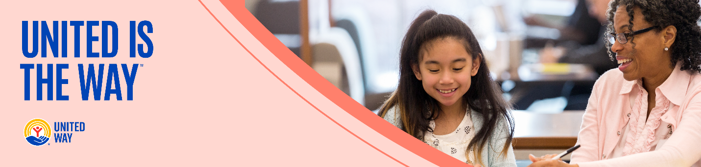
Subject Line: What makes change in Sandusky County possible? People like you!
Email Body:
[NAME],

For 95 years, United Way of Sandusky County has focused on harnessing the caring power of our community to help ensure that everyone can thrive. While the needs in Sandusky County are great, and the challenges are sometimes daunting, we at United Way have the privilege of seeing the very best that our community is capable of.
There’s nothing more powerful than a group of people united to do good. Last year alone, with the help of partners, volunteers, and donors like you, United Way of Sandusky County funded agencies were able to:
- Serve more than 78,616 meals to those in need
- Provide nearly 3,094 young people with positive youth development programs
- Reach 1.7 million adults with financial education and services
- Secure permanent housing for 120 homeless residents
- Support 1,548 people with assistance to meet their basic needs

And we’re not stopping there. Your support can help us continue tackling the biggest problems in Sandusky County. No challenge is too big for us to take on if we work together. Because when people unite to take action, transformational change is possible.

United is the Way™.

Give today and join us in creating more thriving communities for all.
Best Regards,
Jill Simpson
CEO/President
United Way of Sandusky County
director@uwsandco.org

Phase 3: Reminders
Email 3: Reminder – United Way’s Impact
From: Your United Way CEO
Audience: All company employees
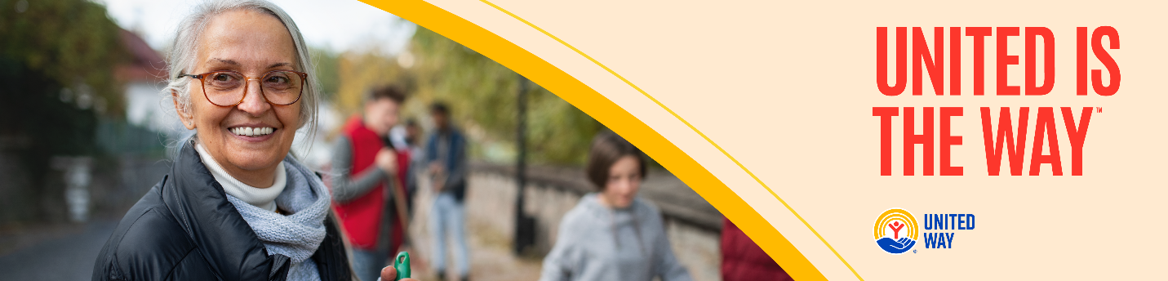
Subject Line: What is United Way doing for the Sandusky County community?
Email Body:
[NAME],
Whether you’re new to the United Way of Sandusky County or you’ve been creating impact with us for years, we want you to consider yourself part of our caring community of hand-raisers, problem-solvers, and changemakers.
At United Way, we believe that everyone who lives and works in Sandusky County deserves the opportunity to thrive. Together with you and all our partners at [COMPANY NAME], United Way mobilizes the caring power of everyday people to create transformational change here in Sandusky County.
United Way of Sandusky County funds programs that meet the most urgent needs in our community. We’re proud of all we’ve accomplished together on behalf of the individuals and families that call Sandusky County home.
If you’ve already made a one-time or recurring gift this year, thank you for being part of our community-led movement for good. If you haven’t, we hope you’ll consider giving by the [DATE] campaign deadline.
A better future is possible when we work together to achieve it. United is the Way™ we can make Sandusky County a community where everyone has the chance to thrive.
Best Regards,
Jill Simpson
CEO/President
United Way of Sandusky County
director@uwsandco.org

Phase 4: Thank You

Email 4a: General Thank You to All Employees
From: Your United Way CEO
Audience: All company employees

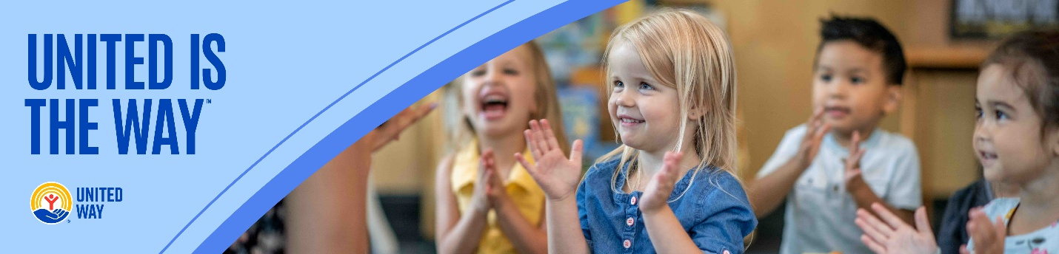

Subject: [COMPANY NAME], thank you for your impact!
Email Body:

Dear [NAME],
Join me in celebrating the success of the 2025 [COMPANY NAME] United is the Way employee giving campaign.
I’m thrilled to report:
• [COMPANY NAME] employees gave $ [DOLLARS PLEDGED] to United Way of Sandusky County
• [PARTICIPATION RATE%] of [COMPANY NAME] Employees gave to United Way of Sandusky County
• [NUMBER OF DONORS] of [COMPANY NAME] employees gave to United Way of Sandusky County

Let’s continue changing lives and transforming communities in Sandusky County!

United is the Way™.
With gratitude,
Jill Simpson
CEO/President
United Way of Sandusky County
director@uwsandco.org

